10th February 2023
Crookhill Community Primary School
Hexham Old Road
Ryton
NE40 3ES
Head Teacher:
Miss K McCormack
Tel: 0191 4334066
www.crookhillprimary.org
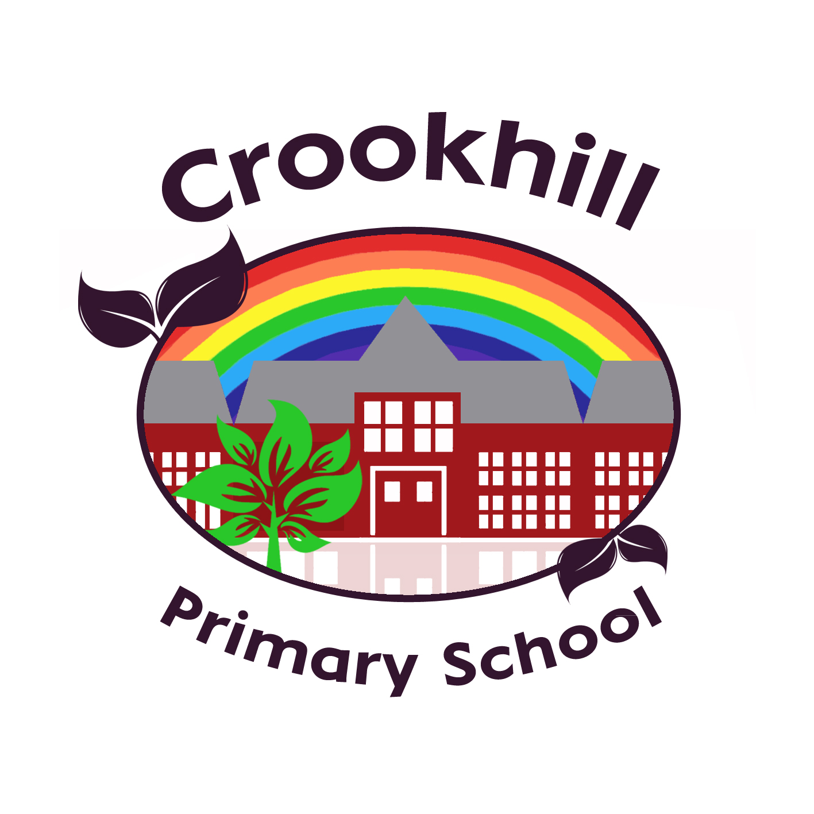
FRIDAY LETTER
Dear Parents and carers,

Children’s Mental Health Week
It has been Children’s Mental Health week and the children have been thinking about their wellbeing in PSHE lessons.
In Reception the children talked about what makes them feel happy and why these things are important.
The children thought about these special things with Mrs Jordan and Mrs Allinson whilst listening to relaxing music, with cucumber on their eyes.
In Year 5 the class looked at what it means to be connected to others and created a web of all of their connections as a class. They discussed who they could go to when they wanted to have a connection with someone. They made paper chains to show how they are all connected and decorated their links with things that make them happy and what they would want to share with others.
Year 4 also looked at their connections within the class, they did this by playing class bingo and explored how the things they like and enjoy doing connect them together, making paper chains to show the links of connection and togetherness.
In Year 2 the children read the story ‘The Invisible String’ and thought about all the people they are connected to, even when they can't see them. They also completed an activity which helped them to think about the things they can do that make them feel good. Check our Facebook page to see some examples of work.

Year 6 Basketball
Having made it through to the Cluster Finals, our Year 6 Basketball Team went to Whickham school on Monday afternoon to compete against the other top local school teams. After a shaky start, and displaying the ever-present good sportsmanship, Crookhill secured the bronze medal. Huge well done to everyone who took part, a great team effort!

Uniform and Earring Reminders
Can we remind parents that children should be wearing the correct uniform every day. Grey trousers, skirt or pinafore, white or red polo and a red sweatshirt or cardigan. School shoes should be plain black and all children should have the correct PE kit for PE days, school house colour T shirt and school house colour hoodie and plain black joggers, leggings. Earrings and other jewellery, other than a watch, should not be worn in school for Health and Safety reasons.

World Book Day
Thursday 2nd March is World Book Day and once again we will be celebrating by dressing as our favourite characters, reading our most loved stories by our favourite authors. Children are welcome to attend school dressed as a character or in non-uniform, whichever they choose.

Year 2 Open Afternoon
We would like to invite the parents and carers of Year 2 to our open afternoon on Thursday 16th February at 2pm. The children will tell the story of ‘Eddie the Penguin Saves the World’ through performance and song, delivering the important message of how to save our planet. We hope to see you there.

Enjoy your weekend.
Yours sincerely,
Miss K McCormack
Head Teacher

Online Safety Newsletter

At Crookhill Primary School, we talk to and teach children about how to stay safe online throughout the school year in computing and PSHE lessons, assemblies and through special events such as Safer Internet Day and Anti-Bullying Week. The online world is a wonderful resource and a great way of staying connected with friends and family but it is important that children understand the risks and know what to do to stay safe. As adults it is important that we know and understand how to keep children safe when online. Below is some information about what the children have been learning and where to find help, support and advice.

Safer Internet Day
On Tuesday, classes celebrated Safer Internet Day with a range of activities. The theme this year is ‘Want to talk about it? Making space for conversations about life online’ and that is exactly what we have been doing all week. In Monday’s whole school assembly we focused on how to stay safe and what we do in school to keep children safe.

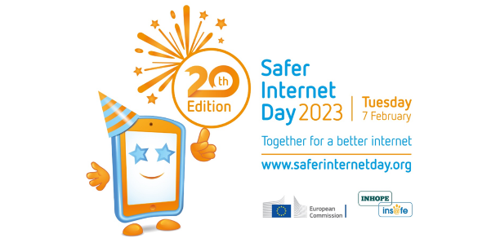

Throughout the week, children have been reminded about the SMART rules:
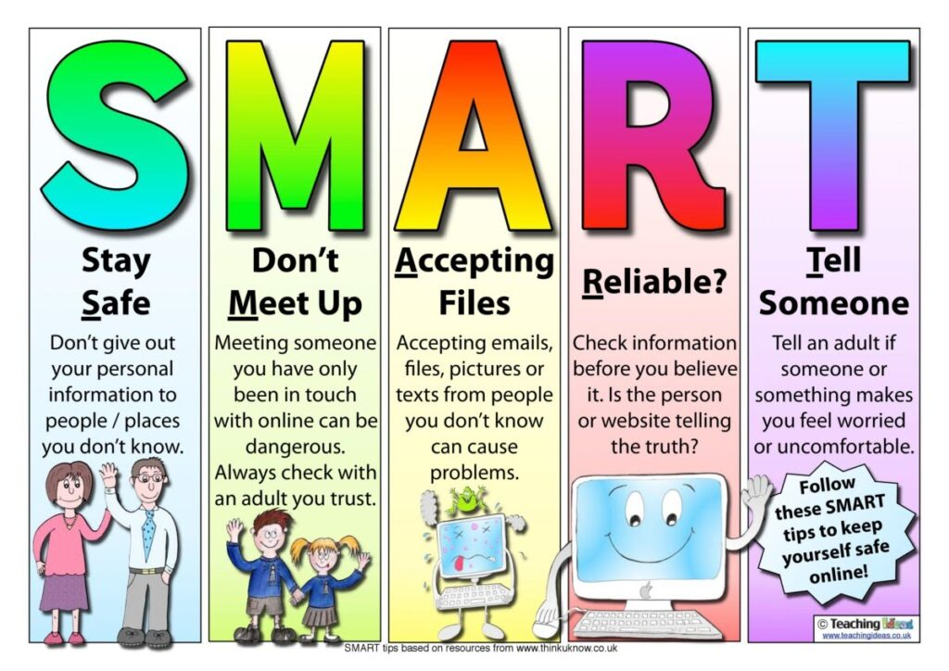
Some classes took part in the BBC Live Lesson on Tuesday. This lesson challenged children to solve online safety issues in the fictional 'Digital Defence Squad' game. Solving problems meant they could unlock advice from famous gamers and cyber savvy celebrities. They also explored some of the risks of online gaming and children were able to share their thoughts of how to stay safe online.

Y5 discussed what it means to be able to talk about what we have seen online and about what some of the things we wanted to talk about were. The children looked at how reliable information is online and how it can be so easily changed or be misleading when we only get to read about one side.

Reception listened to Buddy the Dog’s Internet Safety Story and the song that goes with it about staying safe. Year 2 looked at the story #Goldilocks, learning that once they have pressed send, their images and messages cannot be unsent.

On Wednesday, Rebecca from Big Foot Arts joined Reception, Year 1 and Year 2 with her workshop ‘Boo gets cyber smart’. The children learnt key messages including:
- Be kind
- Don’t give out personal details
- Tell a grown up
- Limit your time online
- Turn on parental controls
Some classes looked at what they enjoy when online and Y4 came up with an A-Z list of what they like. Children also talked about their concerns and worries and created stories about how to help others and how to deal with issues online that make them worry.

Parents and Carers
Parents and carers play a key role in helping children to stay safe online, so it was great to see so many parents and carers at our Online Safety session for Years 2 -6. The children started the afternoon with a fabulous song about how to behave online. Then Miss Hedley and some children from the different classes shared their E-Safety work with everyone from how to deal with cyberbullying, to digital footprints to checking where information online comes from, the children showcased the vast amount of knowledge and understanding they have regarding online safety. Donna Harrison, from Clennell Education Solutions, joined us and shared information about how parents can effectively support their children when it comes to the online world especially as they get older and how they can reduce the risks around this. Donna’s session was really interesting and full of helpful advice – we hope everyone who joined us found it useful.
If you want further information about how to help your children stay safe, there are lots of websites with top tips and advice:
https://www.childnet.com/
https://www.internetmatters.org/
https://www.thinkuknow.co.uk/
https://www.nspcc.org.uk/keeping-children-safe/
Our E-safety Policy and ICT Policy can be found on the school website.
Key contacts in school:
Designated Safeguarding Lead – Miss McCormack
Deputy Designated Safeguarding Leads – Mrs Kelly and Mrs Smith
As always, we are here to offer support, help and advice. Please speak to a member of staff if you have any worries about online safety or any other concerns about a child.

